LaNier, Robert

CSC314

Lab 01 Screenshots

These shots are in reverse order with the last shot first. Trying to test how to print in hex digits as well as how to add spaces after each byte. I wasn’t successful ☹

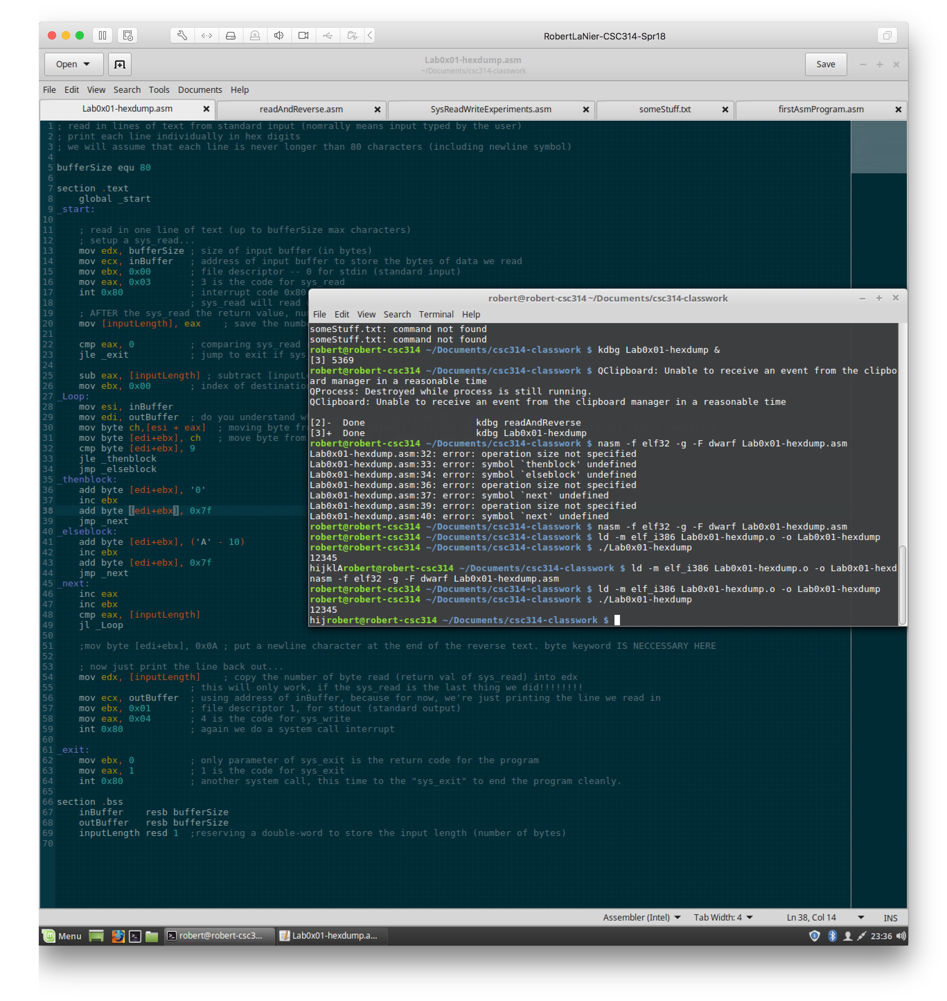

Now I’m trying to figure out the calculation to print the hex digits from ascii code.

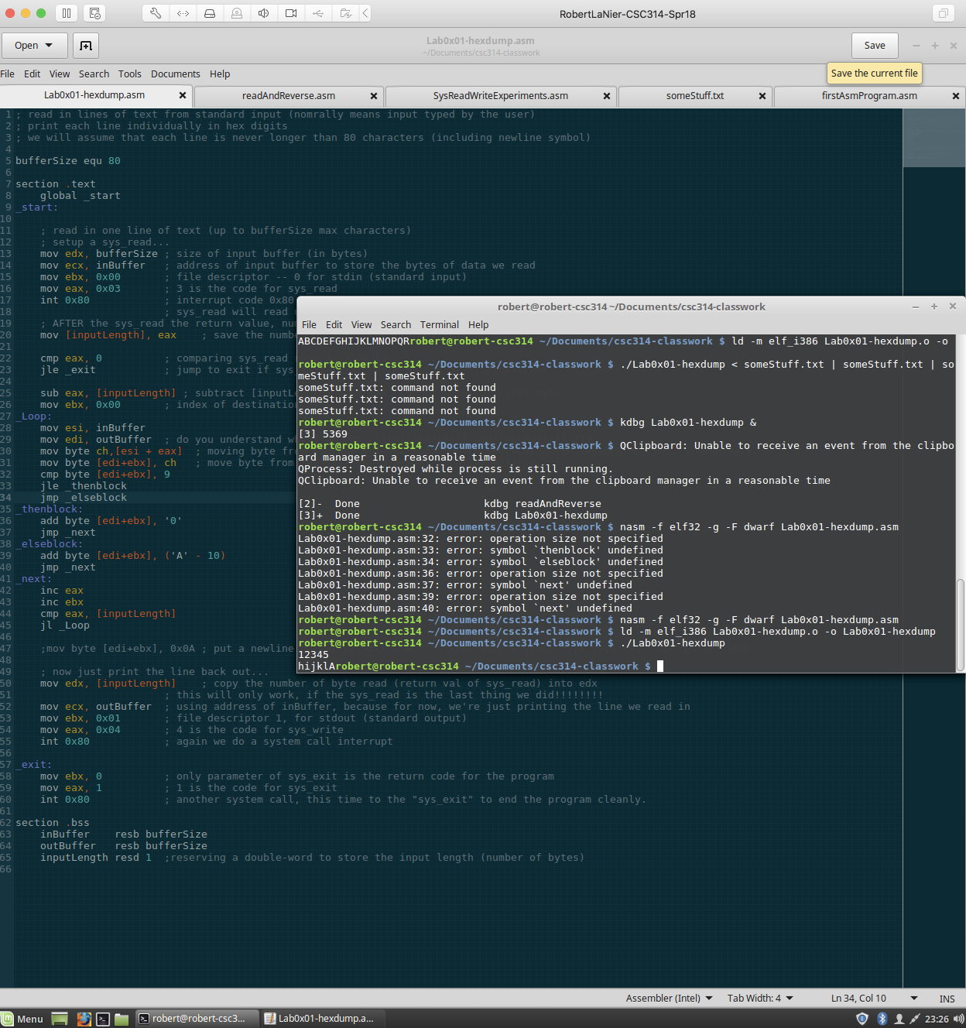

I bad moment when I got a bunch of errors because I forgot to state byte in front of operand.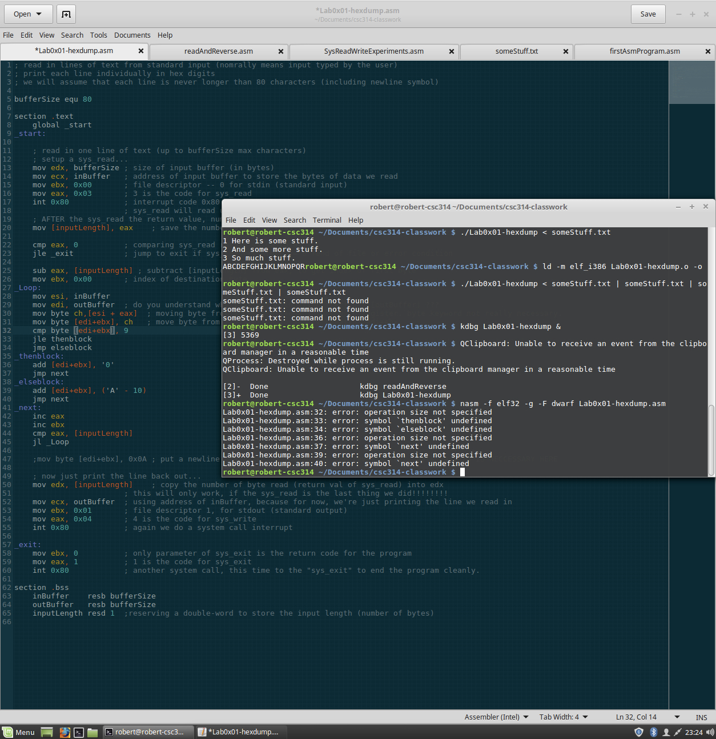

Using kdbg to test out if my program is behaving as it should before figuring out how to convert bytes to hex digits.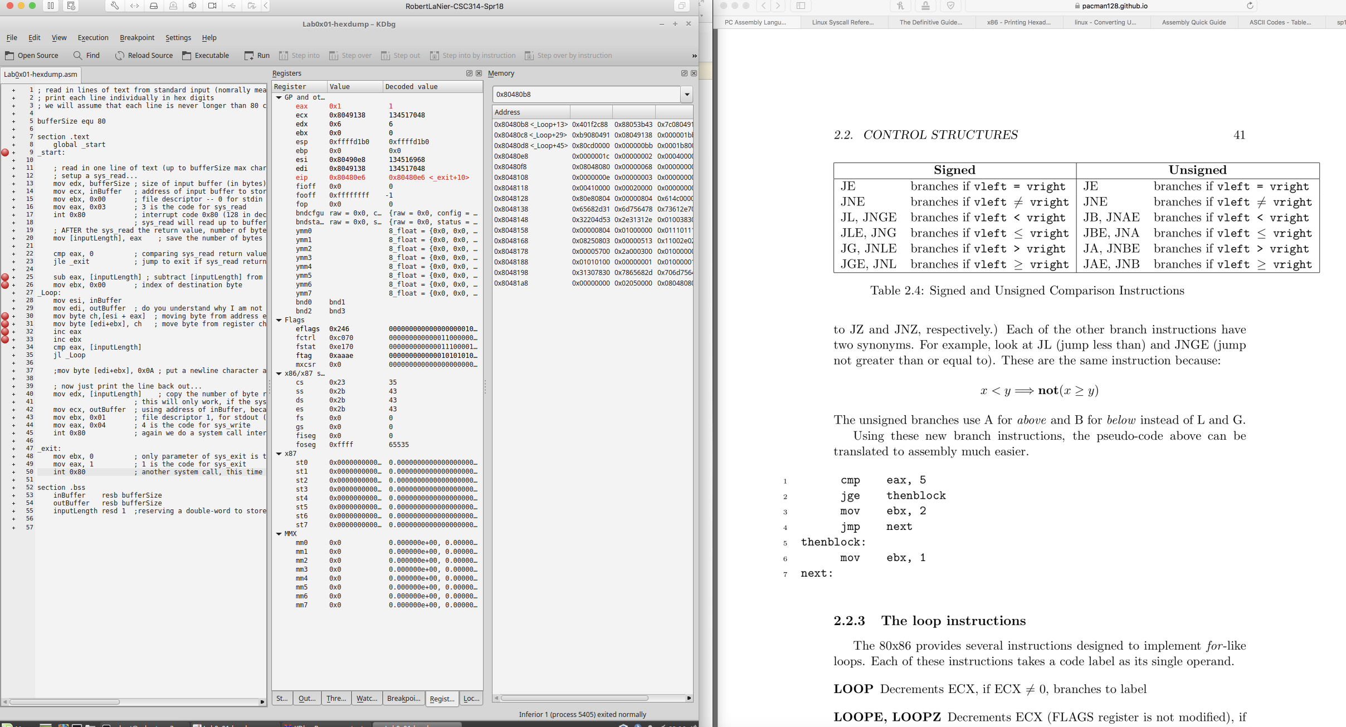

Testing the input redirect with my new program.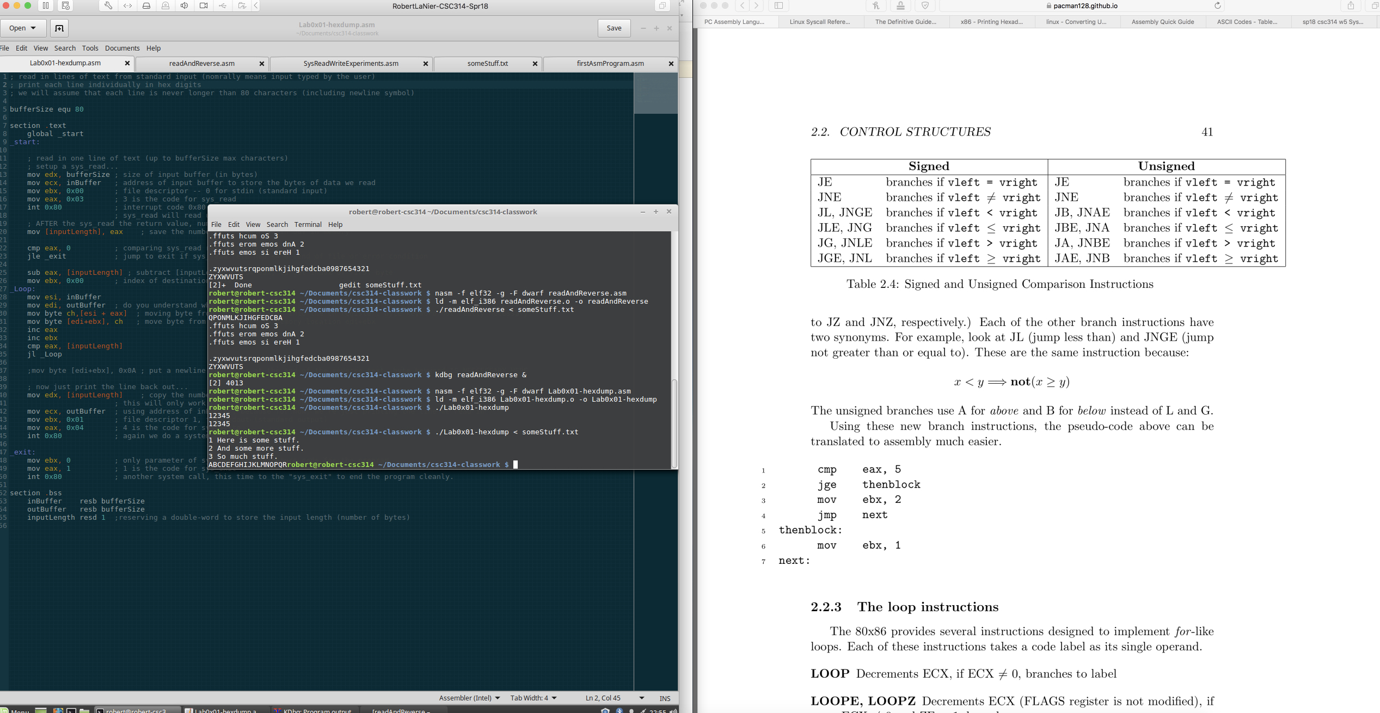

A happy moment when I figured out the process of printing by byte in the correct order.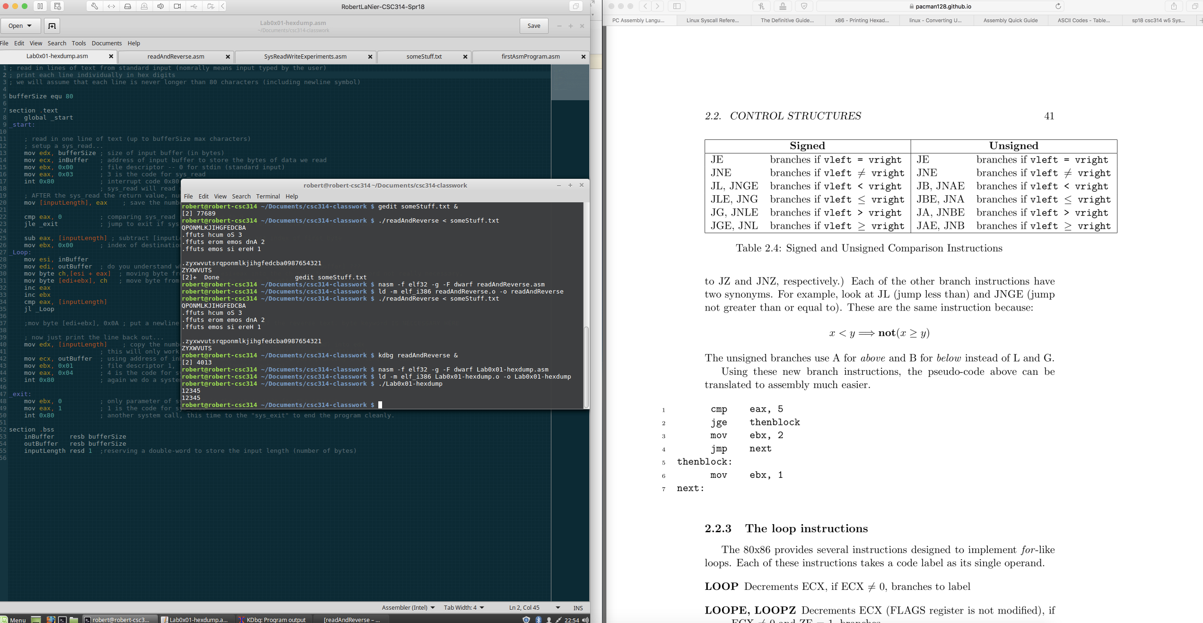

Compiled and linked my new program without errors.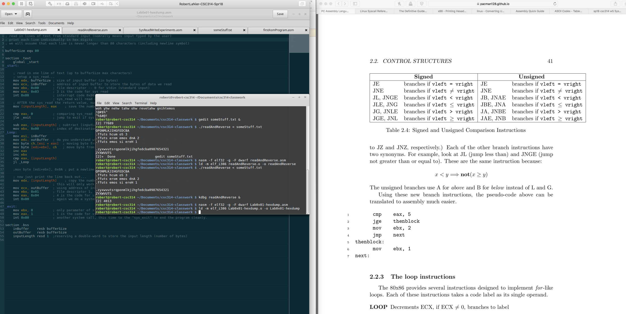

The picture below is where I was testing the program to get better understanding of what was happening with the calculated address operands.

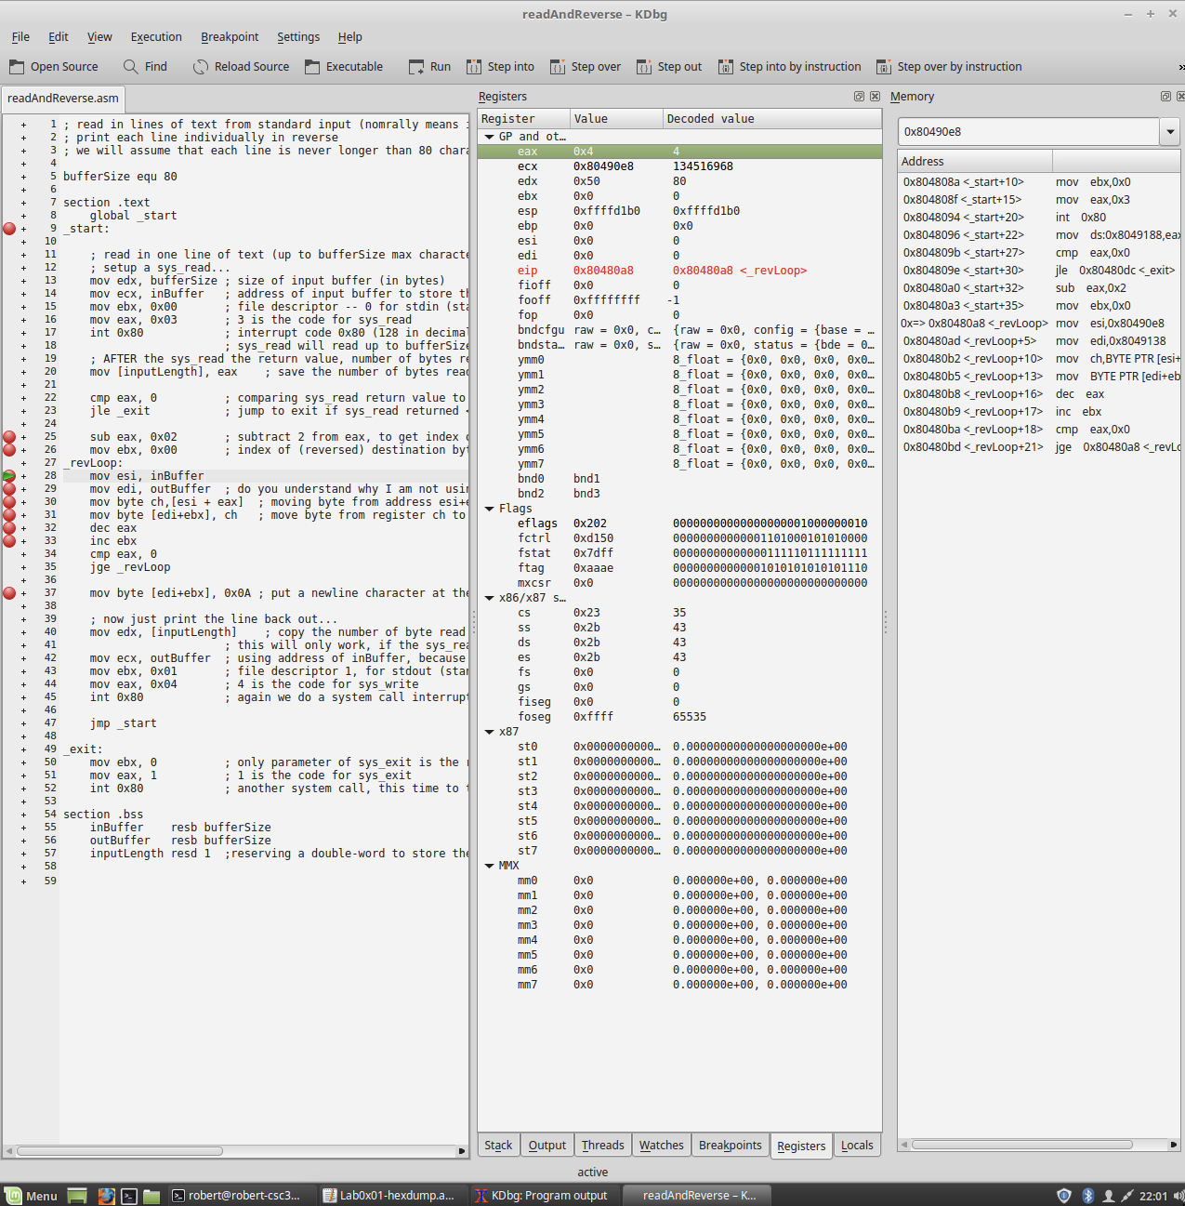

This picture shows me trying to understand the revloop so I can use it to create my loop for printing out the hex digits of the characters.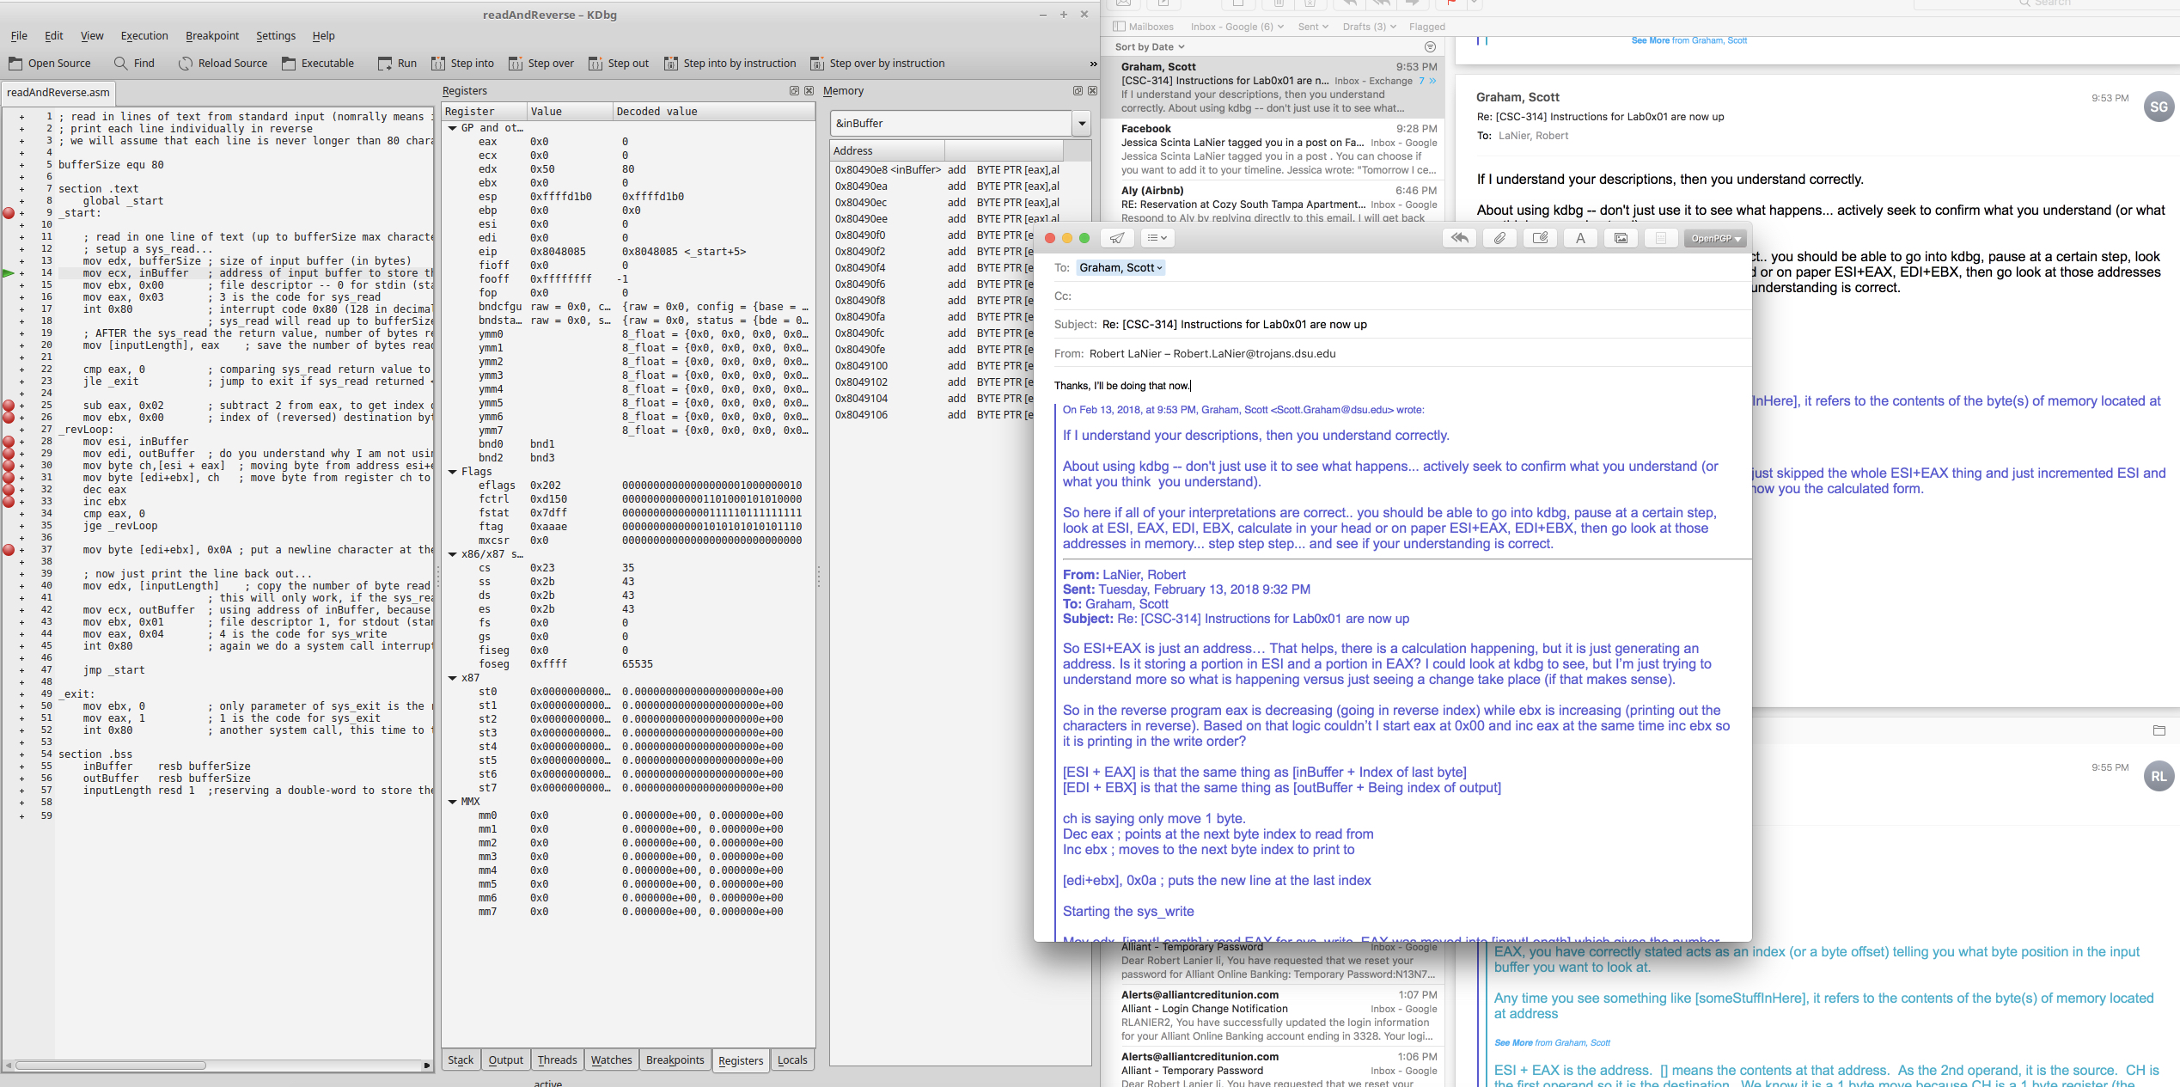

Creating my lab program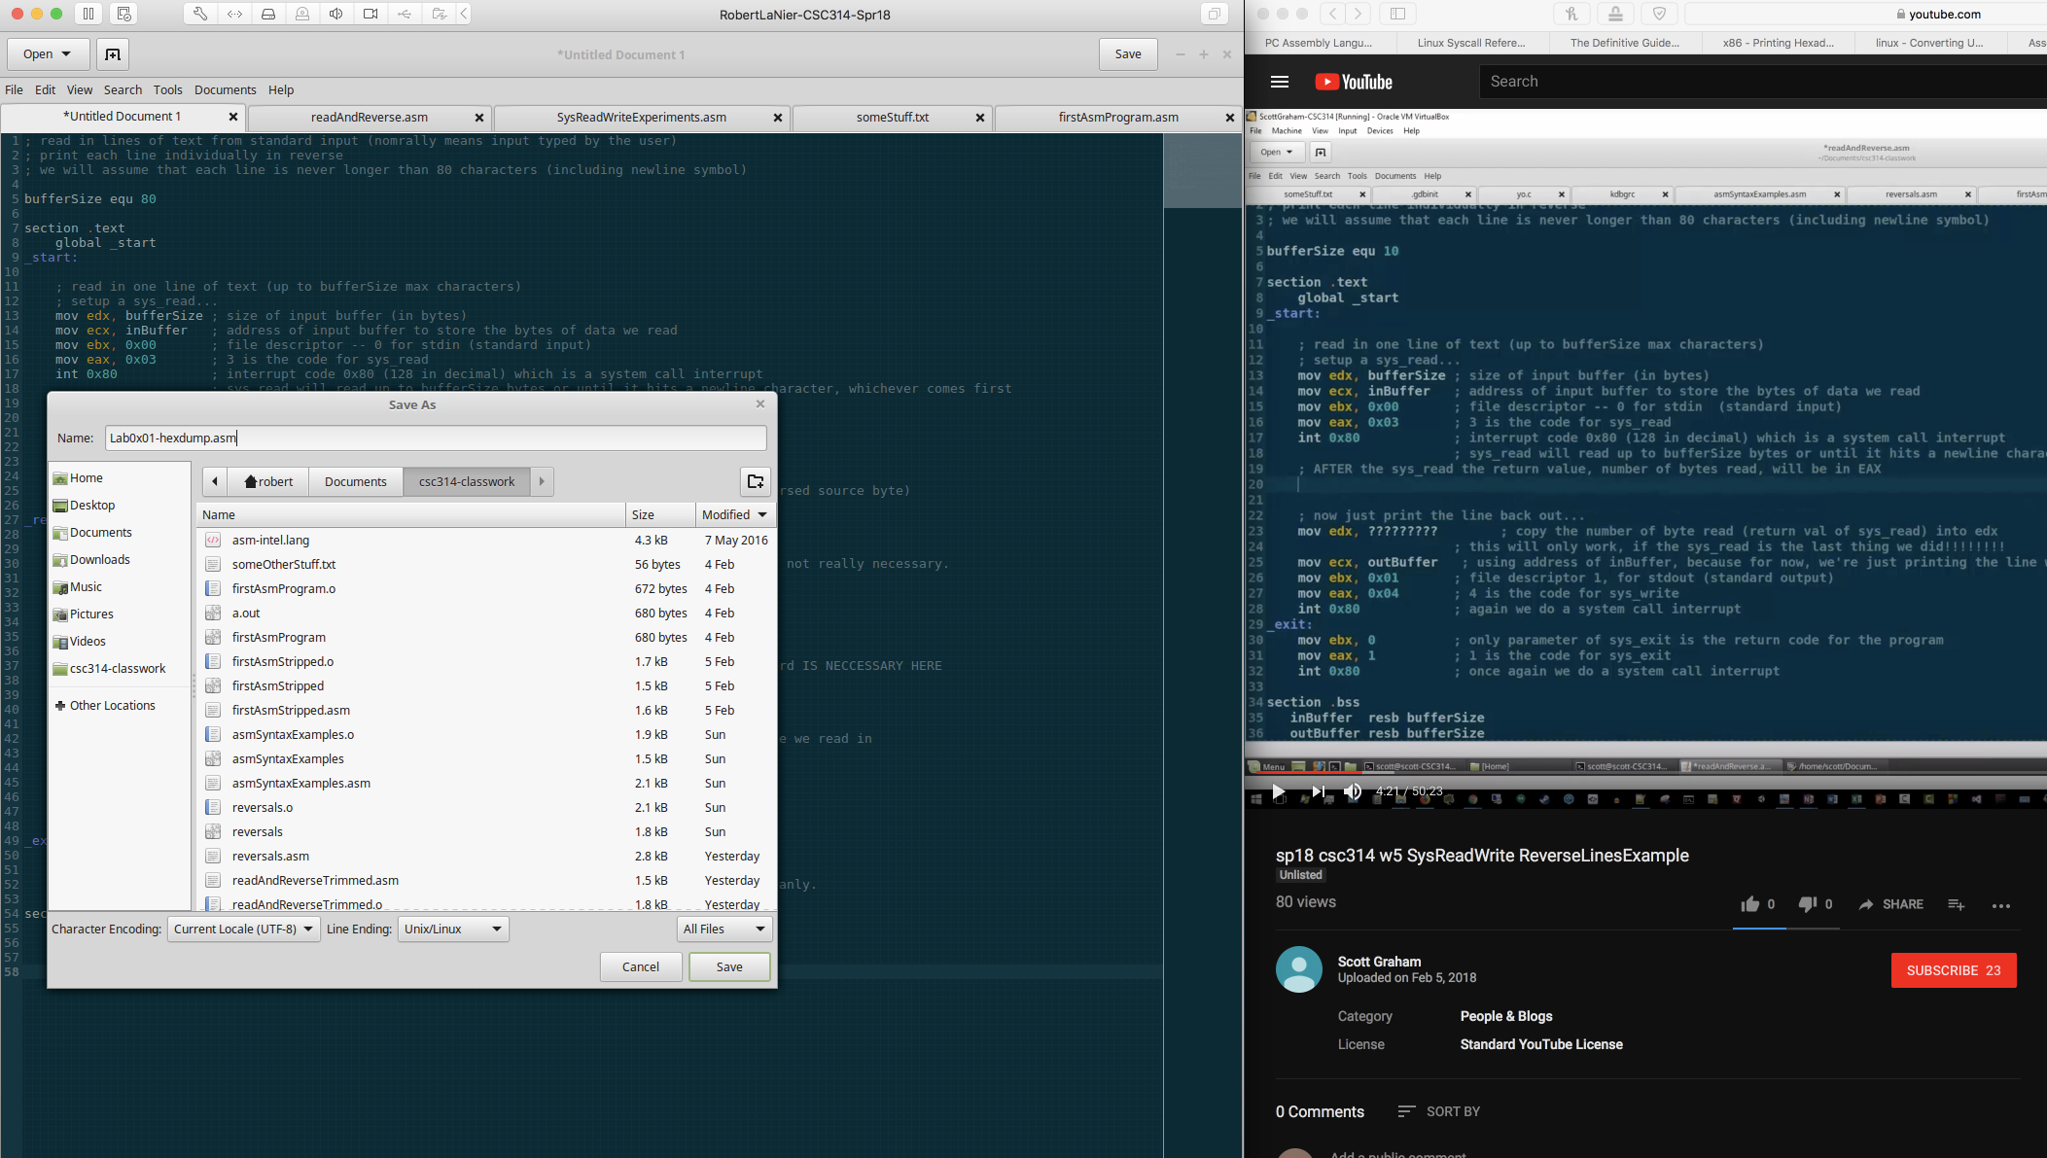

Next shot below I was emailing the instructor my questions regarding my hypothesis.

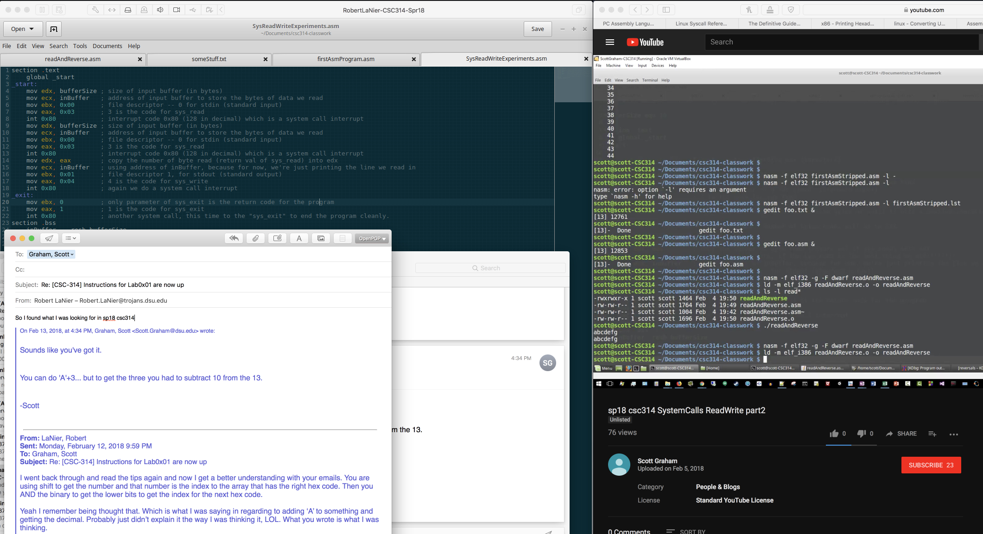

First screenshot. I was watching the video while going through the program for better understanding.